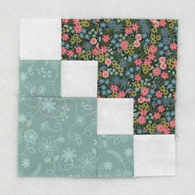
Fast & Fun: Easy Double Four Patch Quilt Block Tutorial
By: Elaine Huff
Fabric Requirements
Light/White | - (4) 2.5in Squares
Light Color | - (1) 4.5in Square  - (2) 2.5 in Squares
Dark Color | - (1) 4.5in Square  - (2) 2.5in Squares
- Use Spring Colors (Pinks, Greens, Yellows, Blues, Purples, etc) for the CPQG BoM
Sewing Directions:
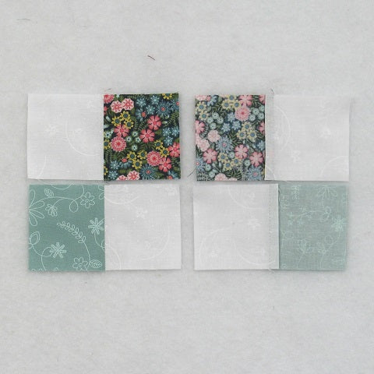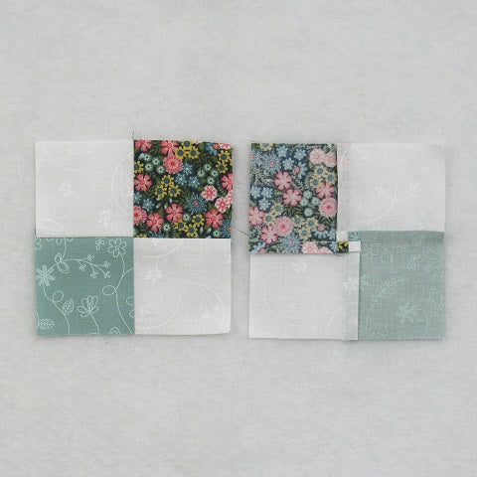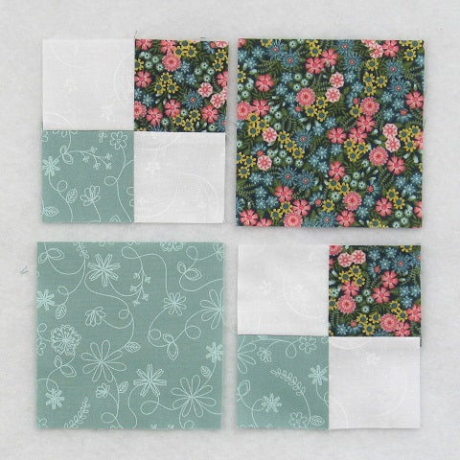
Step 1: Lay out two Light/White 2.5" squares, one Light Color 2.5" square and one Dark Color 2.5" as shown in the top left image. This is the basic four-patch block.
Sew the units into two rows and press the seam allowances away from the White fabric.
Step 2: Sew the two rows together and press the seam allowance. You can see that I've used the tweak/twirl/furl method for pressing but you can press whichever way you like. Repeat for a total of two units. (seen in the center picture)
Step 3: Lay out the two Step 2 units, the Light Color 4.5" square, and the Dark Color 4.5" square as shown in the 3rd picture above. Sew the units into two rows. Press the seam allowances toward the 4.5" squares as shown in the picture below.

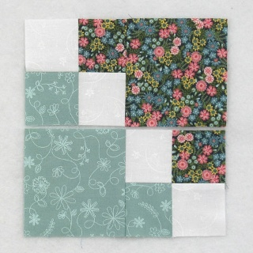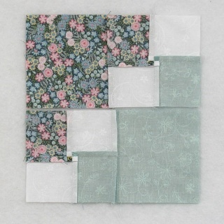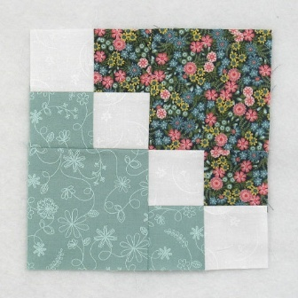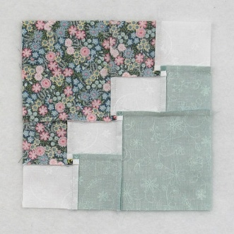
Step 6: Sew the two rows together to complete the block. Press the seam allowances. Once again you can see in the picture above that I've pressed with the tweak/twirl/furl method but you can press how you like.
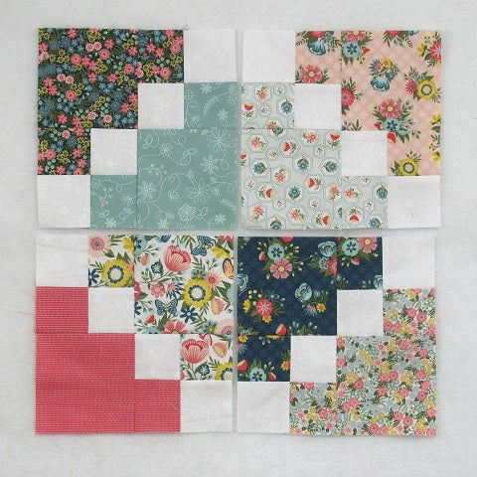
That went together so fast that I couldn't stop at just one block!
Conclusion:
I had a lot of fun with this block! It went together so quick and easy and I was amazed with how many layout ideas it presented!
I hope you have enjoyed this tutorial. If you like it and want to see more, just click HERE to sign up for my newsletter and receive a free PDF quilt pattern called "Chained Weathervane".
Happy Quilting!
Elaine
P.S. Looking for more scrappy blocks? Take a look at these blocks: https://fabric406.com/blogs/fabric406-blog/40-of-the-best-free-scrappy-quilt-block-tutorials
P.P.S. Check out my Etsy shop at https://www.etsy.com/shop/fabric406
Layout Ideas:
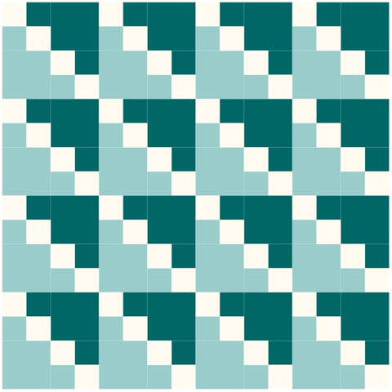 | Here's your basic 4 x 4 layout using colors similar to the tutorial. Kind of boring.
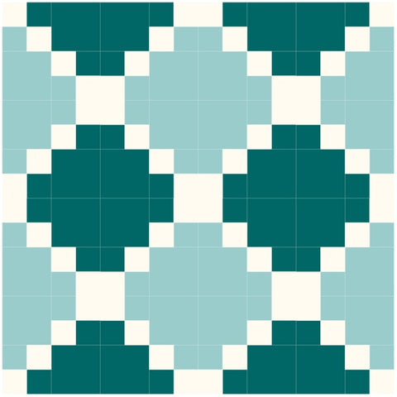 | And this is the same block and layout only the blocks are rotated. Much more interesting.
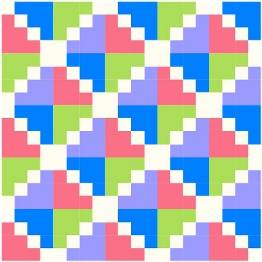 | This example is a scrappy version in a 5 x 5 layout. My favorite!
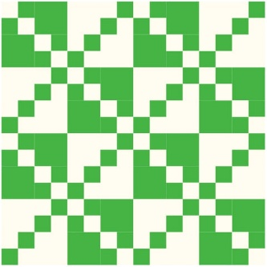 | This version uses a two-color layout with alternating blocks that have opposite coloring. Nice look.
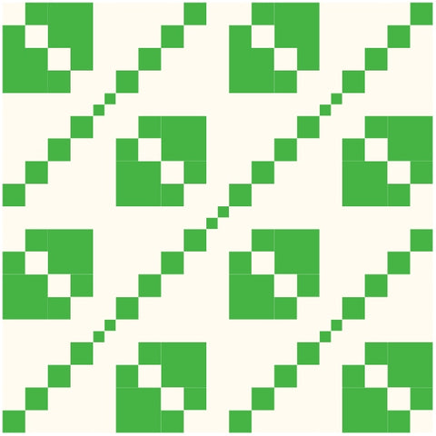 | So this is the same layout as the previous example except sashing and cornerstones were added.
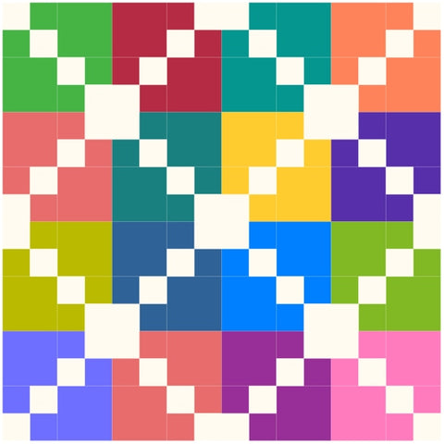 | And this is a scrappy version of the two-color block.
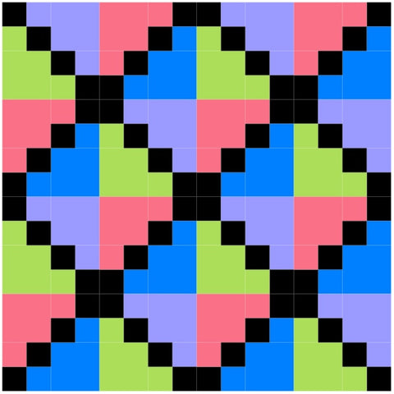 | See what happens when you use black instead of white in the block? So striking!
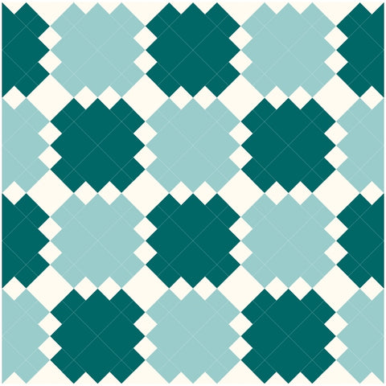 | This is an on-point layout with colors similar to the tutorial. It always amazes me how setting a block on-point can make the quilt look so different!

